John J-H Kim
Sarah McAra

Uncommon Schools (A): A Network of Networks

Brett Peiser, CEO and a founder of the charter school management organization (CMO) Uncommon Schools (Uncommon), entered the office building tucked next to New York City’s famous Strand Bookstore in Union Square and squeezed into the narrow elevator to head up to the ninth floor. Peiser had come to work early this hot August morning in 2013 to prepare for a conference call with the New York City regional board about Uncommon’s students’ recent standardized test results. It was the first year Uncommon’s New York students had taken the statewide test aligned with the rigorous Common Core State Standards (Common Core), and their scores had dropped significantly from the previous year. The results, along with upcoming personnel changes, prompted Peiser and Uncommon’s executive team to completely rethink Uncommon’s strategy.
Uncommon had started in 1997 as one school, North Star Academy, in Newark, New Jersey. Following its success, in 2005 the school’s co-founder Norman Atkins convinced Peiser and other charter school leaders to relaunch Uncommon as a multi-state CMO with a mission “to start and manage outstanding urban charter public schools that close the achievement gap and prepare low-income students to graduate from college.” Acknowledging the common school movement of the 1800s, these leaders realized that children from low-income, urban families did not need common schools. Instead, they needed “uncommonly good, extraordinary, autonomous, and distinctive” schools to help them close the academic achievement gap with their more affluent peers. Guided by the motto “Be Uncommon. Change History,” they set out to “change history” by providing students with a high-quality college preparatory education that would lead to a four-year degree and increased opportunities. Uncommon had made great strides towards this goal and by the summer of 2013 had 32 schools in five regions in New York, New Jersey, and Massachusetts that served 8,000 students in kindergarten through 12th grade (K-12). Its students, 80% of whom were low-income and 98% of whom were African American or Hispanic, consistently outperformed their peers at public district schools.
Having spent days analyzing the 2012-2013 test results, Peiser needed the reminder of Uncommon’s inspirational motto. Uncommon’s students had still performed well relative to others, but their results did not feel strong enough and showed a wider inconsistency across schools and regions than ever before. Uncommon had been following a “network of networks” strategy, which allowed each region to operate with a great deal of autonomy, but the Common Core’s higher standards brought the approach into question. Now Peiser wondered if Uncommon should double down on the network of networks approach or centralize and standardize their schools to ensure high performance at scale.

Charter Schools
In the early 1990s, charter schools were introduced in the United States as a potential source of innovation and solution to educational challenges facing urban communities. Charter schools were tuition-free, government-funded institutions that committed to greater accountability in exchange for operational autonomy. They received public funding on a per-pupil basis, the rate of which varied by state, and their educational objectives were mandated by a charter rather than directly by the state or district, as was the case with public schools. Underperforming charter schools could be shut down if they did not meet the terms of their agreements. Charters allowed schools greater flexibility to implement innovative approaches to education that traditional schools and districts could learn from, and teachers did not have to be unionized, unlike most public schools. Charter schools were not typically considered part of a particular school district, meaning that in some cases a student could attend a charter school even if they did not live in its district, and students were admitted via lottery. By 2013, the District of Columbia and 43 states allowed charter schools.
Since the early 1990s, charter schools had risen in popularity but had achieved mixed results. During the 1999-2000 school year, 340,000 students were enrolled in charter schools nationally, compared to 45.7 million in public schools. For the 2013-2014 school year, 2.5 million out of 47.2 million students nationally were expected to be enrolled in 6,465 charter schools. But success had varied. One study on urban charter schools found that in 2013, students at charter schools outperformed those at public schools in math in 26 out of 41 urban regions, had similar results in 11 regions, and had lower results in 4 regions. In reading, students at charter schools outperformed their public school counterparts in 23 out of 41 urban regions, had similar results in 8 regions, and lower results in 10 regions.
As charter schools proliferated, CMOs emerged as one way to institute successful educational practices at multiple schools. CMOs were non-profit or for-profit organizations that managed multiple charter schools either closely guided by shared practices and philosophies, such as New York City’s Success Academy, or loosely guided by them, such as the multi-state CMO KIPP.

Uncommon Schools: A Network of Networks
Peiser had a deep-seated passion for education and was optimistic about the role charter schools could play in fostering academic success. The son of two New York City public school teachers, he received a Bachelor of Arts (BA) degree from Brown University in 1990 then returned to Brooklyn to teach high school history for four years. He went on to earn a master’s degree in public policy from Harvard Kennedy School, then in 1998 teamed up with a fellow alum to found Boston Collegiate Charter School in Boston, Massachusetts. They built the school on the premise that students in urban areas needed a new kind of educational environment, maintaining that schools needed more flexibility to try new things and that there was no one answer for improving education. After all, Peiser’s belief system was that “there is no such thing as a 100% solution, only a hundred, individual 1% solutions.”
In the years before Uncommon formalized its mission in 2005, Peiser met several charter school leaders who held a similar view on education reform and were running various charter schools. One was Atkins, who had co-founded and co-led North Star Academy Middle School in Newark in 1997 with esteemed teacher and school leader Jamey Verrilli. With a BA from Brown University and a master’s degree from Columbia University Teachers College, Atkins had previously worked as a journalist and as the co-executive director of a New York City non-profit. Atkins described that the initial vision for his school “began with the belief that we could give students a rigorous college preparatory education inside of a warm, loving, learning community.” Other charter school leaders included John King and Evan Rudall, founders of Boston’s Roxbury Prep, and Doug Lemov (MBA 2004), a founder of the Academy of the Pacific Rim school in Boston. (See Exhibit 1 for biographies.) They had all helped their students achieve impressive results. For instance, within a few years of Roxbury Prep’s opening, its eighth graders earned the highest scores on Massachusetts’ standardized tests. And at Boston Collegiate Charter School, 100% of its tenth graders earned proficient or advanced in math and reading every year. These leaders grew close and often shared insights from their respective experiences. “I remember going to visit Roxbury Prep early on, looking at the way John [King] was overseeing teachers and the way Evan [Rudall] was monitoring student information systems,” said Peiser. Peiser, in turn, shared with them his best practices for discipline.
By 2005, Atkins had convinced all of them to join together as one to replicate the successes of each leader’s original school by relaunching Uncommon as a CMO to oversee five independent, high-performing charter schools in New York and New Jersey, serving around 600 students. The schools were managed as part of distinct networks, but were aligned under Uncommon’s strategy and philosophy of improving education through joy and rigor. The leaders believed that longer school days and academic years would bring greater results and, as Atkins said, that “every minute of the day has to be a moment of urgency.” They also focused on teacher and leader development. Atkins explained, “What we’ve had for far too long are adults who have not been coordinated with each other in creating classrooms and schools and learning opportunities so that all schools can fulfill their promise.”
Uncommon’s network of different charter school networks was organized into a three-tiered management model featuring a central home office, regional managing directors that functioned like district superintendents, and school-level leaders. Peiser, King, and Lemov all became regional managing directors, while Rudall became the chief operating officer (COO) at the home office. They all reported to Atkins as CEO, along with Norman’s successor at North Star Academy, Paul Bambrick-Santoyo. (See Exhibit 2.) The home office supported the network to free up time for regional and school leaders to focus on student achievement. Its services included staff recruitment, human resources, facility acquisition and financing, financial management and fund development, and technology. The home office was funded by an 8% to 10% management fee that each school paid for the services, but it also raised additional private capital funds.

Regional Leadership
As the networks began to scale, each managing director began working with a regional COO to run each region. The managing director had complete autonomy over academics. As Uncommon described it, each one “develops a school’s cultural blueprint, manages start-up by designing programs and training the school leaders, supervises and coaches school leaders on an ongoing basis, and ensures the success of each school’s instructional program.” The managing directors implemented Uncommon’s core philosophies however they saw fit. Peiser recalled his time in the role: “With each of us having programmatic autonomy, I didn’t have to justify my decisions, so I could experiment. In my first year, I tried a new reading comprehension program. I quickly realized it was too cumbersome and didn’t work for all of our teachers, but that was okay. We just got rid of it.”
And, while the regions were independent, the managing directors often turned to each other for support or inspiration as they had in their previous roles as school founders. In 2006, they formalized these meetings by starting School Inspections, where managing directors and other leaders visited each school in the organization to assess instruction. They provided schools with specific feedback and used the opportunity to identify best practices that could be spread to other schools.
Four COOs oversaw the non-academic side of regional management, such as school operations, facilities, technology, finances, and external relations. Josh Phillips, COO since 2008, explained the dynamic between the COO and managing director: “They have a tight relationship and talk to each other all of the time, either in regular one-on-one check-in meetings or during more casual conversations (e.g., when they are driving together to visit a school). They map out the vision and execute the strategy for a region together.” As the network grew, COOs began to oversee associate COOs, who managed the directors of operations at each school.
The home office encouraged the COOs to bring their own approaches to operations as long as the resulting systems enabled principals and teachers to provide the best learning environments for students. Phillips described some of the different styles: “One COO is very data-driven and systematic and has a clear philosophy on how directors of operations should run their schools. But another is more hands off with a philosophy based on hiring extremely intelligent and talented school-level leaders and giving them a framework for how to run a school. That COO holds them accountable for their performance but lets them execute on the framework, believing that they may find more innovative ways to do things.”
The organization’s flexibility had allowed Uncommon to enter the regions through different avenues. For instance, they moved into Upstate New York because of Lemov’s desire to build schools in struggling smaller cities and entered Boston by adding Roxbury Prep to the organization. This resulted in different operating environments with varying city and state charter school laws. For example, Massachusetts required Uncommon to fully backfill students (i.e., enroll new students when existing students left) in half of their grades, while Newark had a universal enrollment system that placed students at public and charter schools via lottery based on family preferences. And while Uncommon was allowed to use district school buildings in New York City, it had to find private facilities in other regions. Each region also had different pain points. The talent pipeline and staff diversity were prominent issues in Upstate New York, while Boston had charter laws that prevented the CMO from opening elementary schools, as well as high real estate costs. In Newark, old facilities were in poor condition, and new facilities were expensive. And in New York City, Uncommon had to undergo a time-intensive process to access underutilized district facilities.

Structured School Design
Despite regional differences in academics and operations, at the school level some elements were present across Uncommon. Like the regions, schools had a dual leadership model, with an instruction-focused principal paired with a director of operations. The principal was primarily responsible for curriculum, assessment, and managing teachers through observations and trainings. The director of operations oversaw non-academic tasks such as transportation, finances, human resources, and facilities. (In most public schools, principals oversaw both educational and operational activities.)
Uncommon schools also shared rituals and practices. For instance, schools embraced the college preparatory mission by naming homerooms after their teachers’ respective alma maters. Another shared ritual at most schools was the community circle, which one observer described as “a spirited school-wide gathering involving African drums, call and response, academic exercises and awards—pretty much everything, all done loudly and at full speed.” All schools also followed a strict dress code to reduce distractions, as well as a behavior management system (e.g., merits and demerits or paychecks) predicated on high expectations of behavior. Some networks measured their schools’ cultures to ensure consistency. For example, the North Star Academy network used a cultural rubric that included standards for how its schools ran breakfasts, organized community circles, choreographed dismissals, and more. (See Exhibit 3 for an example.)
Each school also developed a highly structured schedule to maximize the time spent on academics. (See Exhibit 4 for a typical school day.) Uncommon schools had longer school days and longer school years than traditional public schools, and several offered after-school tutoring and Saturday programs. Students at Uncommon’s New York City schools, for example, had 25% more instructional time per year than those in the city’s district schools. Moreover, Uncommon trained teachers to use time efficiently, with techniques for tight transitions between topics or for passing out papers during class. Aspects of instruction were also shared across the networks. For example, teachers used a common blackboard configuration—Do Now, Learning Objectives, Agenda, and Homework—and instructional leaders reviewed teacher-written lesson plans before class.
Data was another central facet present in each network. “We collect data daily to change our instruction either that same afternoon or the next day,” said one principal. To track long-term progress, each managing director devised quarterly interim assessments for his or her region. The assessments compared a cohort’s performance by grade and subject to the previous year’s cohort’s performance. The results were not intended to meet specific goals, but all schools strove for constant improvement. School leaders used this data to gauge results and make plans for instructional changes. Bambrick-Santoyo noted that, after spending 10 years observing schools, “I am convinced that data-driven instruction is the single most effective use of a school leader’s time.”

School Staff
Hiring and training teachers who were committed to Uncommon’s mission was key to student success. However, early on, building a strong teacher talent pipeline proved to be a potential barrier to expansion. Uncommon had preferred to employ experienced teachers from the public school system, but the CMO increasingly competed against other emerging charter schools for the best talent. In addition, some contended, top teachers might not want to work at charter schools due to the longer school days and years. Expanding into new regions brought another challenge, since some areas, such as Upstate New York, had relatively fewer qualified candidates than others, such as New York City.
The limited teacher talent pool also affected Uncommon’s leadership pipeline. “We have a high bar for leadership, so most of our leaders are home-grown,” said Chief of Staff Laura Lee McGovern (MBA 2007). “That means we may train a successful instructional leader to be a principal, but then we need to find his or her replacement.” Julie Jackson’s experience demonstrated this path to leadership. She had started as a teacher at North Star Academy in 1998 and gained wide acclaim for her teaching skills. She then became the dean of students of North Star Academy for two years, then the founding principal for North Star Academy’s high school for five years. Next, she launched and served as principal for North Star Academy’s first elementary school, and then became the associate managing director in Newark. In 2012, her role expanded to include all elementary schools in Newark and Brooklyn—Uncommon’s first foray into cross-regional management.

Training Teachers
In 2008, Peiser and his colleagues realized that they were “thinking about the talent pipeline all wrong,” he said. “We were trying to hire the best teachers out there, but we decided we should grow our own.” Spearheaded by both Lemov and Bambrick-Santoyo, they set out to codify best practices to train all of the new teachers they would need to expand. “Lemov’s view is that getting students to pay attention is not only crucial but also a skill as specialized, intricate and learnable as playing guitar,” wrote one reporter. Bambrick-Santoyo elaborated on their approach: “If the word in a kindergarten class’s vocabulary lesson is inquisitive, we’ll film a teacher going through the hundreds of tiny actions that allow students to understand that a person who asks a lot of questions is inquisitive. Then we edit it into a short training video our teachers can watch.”
To find the most effective teaching techniques, Lemov examined student test scores to identify the teachers who were achieving the best results, then observed and recorded their class sessions and distilled their most effective techniques for classroom management (as opposed to academic content). After much analysis, he developed “The Taxonomy of Effective Teaching” with 49 of these proven teaching techniques. One was using “positive framing” to correct student behavior by focusing on positive outcomes instead of chastising bad behavior. Another was called “What to do,” which emphasized giving clear, explicit directions for action (e.g., “Take out a pencil and put everything else in your desk,” as opposed to “Get things ready for class”). “Joy Factor” was also essential, bringing joy to the classroom through surprises, humor, games and excitement.
Uncommon ensured that its teachers learned and applied these best practices through trainings and observations. School principals frequently visited classes to provide their teachers with feedback. “It’s really sped up my learning process,” said one teacher. “It’s great to have another set of eyes in the room.” Atkins explained why giving teachers this level of attention was important: “The history of public education is about teachers going into classrooms and closing their door and being lonely and private. . . . I think blowing those doors open was one of the greatest contributions that we were able to make. And creating a learning lab and community within Uncommon Schools, and eventually within other charter schools, was really helpful in spreading the work that we were doing.”
As this approach demonstrated, the Uncommon team believed that successful teaching techniques were transferable, teachable skills. For example, Uncommon had replicated some of Jackson’s best practices as principal after she had helped her students achieve impressive results: her average elementary student outperformed 99% of all U.S. elementary school students on a nationwide standardized test. Yet as Bambrick-Santoyo wrote in his book Leverage Leadership: A Practical Guide to Building Exceptional Schools, “Julie Jackson is not a miracle worker. Though she is talented, driven, and hard working, Julie’s school has succeeded because of the systems she has put in place and the way she organizes her school.” Replicating these kinds of systems allowed others to follow in Jackson’s steps. Juliana Worrell, for example, joined Uncommon in 2007 as a founding lead teacher at North Star’s first elementary school then became the founding principal of a new North Star elementary school in 2011, and subsequently served as principal at two other North Star elementary schools. As a teacher, she learned to employ several techniques from the taxonomy, and as a principal, she used the taxonomy to give effective feedback to teachers. Her North Star third and fourth grade students consistently ranked in the 99th percentile of all New Jersey schools on the state’s standardized tests.

Source of New Ideas
While all of Uncommon’s instructors received similar training, the autonomy built into the network allowed teachers to execute the techniques in their own ways. From the beginning, Uncommon encouraged teachers and school leaders to learn from each other, with the hope that some of the best ideas could be spread throughout the organization and beyond. “We felt that this was the R&D [research and development] arm of public education and that we really wanted the work that we were doing to create more opportunities for low income kids across . . . the United States,” said Atkins.
Uncommon’s leaders always looked for new ideas to roll out to their other schools. For example, one school had students keep track of all of their notes and materials in a standardized way in their binders, which proved to be highly effective. Uncommon then trained other teachers throughout the network on the technique. In another case, a principal implemented a weekly practice where every teacher met with an instructional leader for 30 to 60 minutes. The teachers saw positive outcomes, and the meetings were spread to all of the schools. “We constantly tweak what we’re doing to be as effective as possible,” said Peiser.
Uncommon’s frequent experimenting resulted in several innovations spinning off from the organization. One came in 2008, when Atkins left Uncommon to co-found the teacher preparatory program Relay Graduate School of Education (Relay, formerly Teacher U), which was initially co-sponsored by Hunter College and charter school networks KIPP, Uncommon, and Achievement First. Atkins and one of KIPP’s co-founders developed the idea when they realized they had been interviewing and vying for the same job candidates. They decided they could “do more and better work together than fighting with each other over the limited talent and resources that were out there.” In 2011, Relay became an independent, accredited two-year education master’s program. In 2012, Uncommon partnered with Relay to launch a year-long fellowship for hundreds of district and charter school principals, designed by Bambrick-Santoyo.
Uncommon’s other leaders also pursued external projects. For instance, Lemov delivered several workshops on instructional techniques outside of Uncommon and had reached over 4,000 teachers by 2010. He also published his taxonomy in Teach Like a Champion: The 49 Techniques That Put Students on the Path to College, which became a best-selling book embraced by teachers around the world. In 2012, Rudall—who had succeeded Atkins as CEO—left Uncommon to launch a new non-profit program called Zearn, which developed interactive, digital K-8 math content for personalized and small-group instruction. Lemov explained why it seemed natural for Uncommon to foster so many new ideas: “I think it comes directly from our federalist structure, where educators from each leg of the federation enjoy independence but also reach out to others for resources and advice. It’s an organization that’s built to learn. It starts with the humility of admitting we don’t have all the answers and we probably never will, so let’s design ourselves, learn as much as we can as fast as we can, and then share. It’s embedded in our culture.

Student Success
With an ultimate goal of helping students secure a college diploma, Uncommon relied on standardized test scores to measure their success along the way. Peiser explained that standardized test scores were important because a student’s performance on early state exams may be correlated with his or her performance on later tests like the SAT, and performing well on the SAT increased a student’s chances of getting into college.
Uncommon admitted students via lottery with no academic pre-requisites nor entrance exams. Typically, students tested two years below grade level at entry in middle school; after two years at Uncommon, the majority outperformed their peers at local district schools, earning more “proficient” and “advanced” scores on standardized tests. One study found that attending an Uncommon school “completely cancel[ed] out the negative effect associated with being a student in poverty.” “With our students, we never accept that some won’t ever ‘get it,’” said one Uncommon principal. “We know that intelligence is not a fixed trait; with the right instruction, and lots of well-constructed practice, all of our students can achieve at high levels.”
Uncommon saw academic gains across all grade levels. For example, 98% of its New York City eighth graders earned proficient or advanced in math in the 2011-2012 school year, compared to 53% of district students. Also in 2011-2012, Uncommon’s high school students had closed the gap with national averages among white students in five out of six Advanced Placement (AP) tests. And since 2006, 100% of North Star Academy’s graduating seniors had been accepted into college, and over 90% had enrolled. By comparison, around 65% of the nation’s middle income students and 51% of low income students who graduated from high school enrolled in college during the same period.
Uncommon had earned numerous distinctions and its schools were in high demand. In the 2009-2010 school year, Uncommon had around 5,000 students on its waitlist, and in the 2010-2011 school year, there were 6,200 students on the waitlist. Its top-performing schools served as models for other educators. In a single school year, 1,100 teachers, leaders, and donors visited North Star Academy. A kindergarten teacher recounted her visit to a North Star school: “I had never seen kindergarten done that way, and I didn’t know you could hold kindergarten students to that expectation . . . . I was really impressed with the idea that you can get kindergartners to read within three months.”

Scaling the Network of Networks
When Atkins left to found Relay, Rudall became Uncommon’s CEO in 2008. At the time, Uncommon had 11 schools in three regions. (See Exhibit 5.) By 2013, Uncommon had 32 schools managed by five regional managing directors: Boston; Rochester and Troy, New York; Newark, New Jersey and New York City elementary schools; Newark middle and high schools; and New York City middle and high schools. (See Exhibit 6 for map and Exhibit 7 for regional data.)

Growing Together
The Uncommon team was very intentional about adding schools to the network and refined and improved the expansion model with every new opening. Important considerations included the availability of facilities, funding, leaders, and teachers. In most cases, the CMO created a new school from scratch, except when they added Roxbury Prep to the network given its original ties to Uncommon. They prioritized expanding within their existing cities to cover all K-12 grade levels in order to start preparing students for college as early as possible. The team also was deliberate about expanding any given school, growing by one grade at a time. An elementary school, for example, started with kindergarten in its first year, then gained a new grade in each of the subsequent four years.
The home office supported each school during its start-up phase with private philanthropic funding to supplement public funding. When an Uncommon school reached full enrollment, typically after three to four years, it was sustainable on the public dollar, meaning that each school ran on the government’s per-pupil funding. A school’s budget covered operational and programmatic expenses, salaries, a contribution to the school’s surplus to cover unknown future expenses, and the management fee paid to the home office. (See Exhibit 8 for expansion and financial data.)
While Uncommon gained efficiencies from its size and financial resources, it still faced some challenges in expanding. Finding a school facility was a time-consuming and costly undertaking, requiring working with several stakeholders. Moreover, most buildings needed substantial improvements. For instance, the building for the Excellence Boys Charter School in New York City was a “former school building that over the years had transitioned from a Yeshiva school that was torched in a mysterious fire to a den of iniquity.” Another building in Rochester, which had once been a church-owned school, required major renovations including installing air conditioning, replacing windows, refurbishing floors, adding walls, updating electrical needs, and more.
As Uncommon scaled, the networks differentiated from each other. New York City middle schools became known for a strong staff culture; Newark thrived in data-driven instruction, discipline, and community; and Rochester developed an effective rewards and recognitions system. The managing directors saw what the others did well and often tried to replicate it. They also learned from other charter schools. Wrote one observer, “From a KIPP school in Albany, [Lemov] learned how to re-do school bathrooms, which for most schools are the source of many discipline problems—from graffiti to the sparks that lead to later-in-the-day scuffles.” He borrowed the idea to decorate the bathrooms with carpets, ferns, and posters to make them look like respectable places to foster better behavior.
The differences in the leaders’ styles also became more prominent. For example, the Brooklyn middle schools were relatively decentralized. While they shared core beliefs like all Uncommon schools—a longer school day, a structured academic environment, etc.—school-level leaders earned greater autonomy based on results, which led to programmatic differences and an informal sharing of best practices. In contrast, the Newark middle schools developed under a managing director who believed in consistency across the schools. They were tightly aligned, looked similar, and all adopted the same practices.

The Shock: Common Core-Aligned Test Results in 2013
In 2012, Peiser became CEO amidst a changing educational landscape in the U.S. as several states adopted the Common Core. In 2009, several state governors and educational leaders had collaborated to create a set of demanding learning benchmarks that outlined what students across the country should be able to do at each stage of their K-12 education. They were intended to improve the U.S.’s overall competitiveness with other countries by replacing each state’s individual academic standards, which varied in terms of rigor and clarity. The resulting Common Core standards did not dictate content and a curriculum but rather focused on the skills and knowledge students needed to learn at each grade level. For English language arts (ELA), Common Core emphasized analyzing different types of texts, from fiction to complex informational prose, as well as critical thinking and collecting evidence. For math, the standards called for more conceptual understanding rather than rote memorization and computation. (See Exhibit 9 for examples.)
The Common Core brought an ability to standardize testing across states in a way that was never possible before. Each state could choose from two Common Core tests being developed by consortiums. One testing option several states were considering was the Partnership for Assessment of Readiness for College and Careers (PARCC) exam. It was a partnership among several states that had come together to develop and design a test around the Common Core standards. Another was the Smarter Balance Assessment Consortium (SBAC).
By 2013, 45 states and the District of Columbia had adopted the Common Core. In the summer of 2010, Massachusetts, New Jersey, and New York all approved the standards and had gradually implemented them by 2013. These three states were also considering switching to the PARCC exam. However, until the exam was finalized, they had developed their own Common Core-aligned standardized tests, and the high standards of the new assessments caused students’ scores to drop across the board. In 2013, in New York, for instance, 31% of students in grades three through eight earned a proficiency standard or above in math, compared to around 65% in years prior. The same rang true for ELA: in 2013, around 31% of New York students received a proficient standard or above, compared to 53% to 55% in years prior.

Uncommon’s Results: 2012-2013
Uncommon prepared for the Common Core with new professional development for teachers and as many instructional adjustments as seemed necessary at the time. Said Peiser, “For example, we decided that every math class was going to start with a conceptual question instead of something like, ‘This is how you divide fractions.’” Beyond these enhancements, Uncommon carried on with business as usual, unclear exactly what the new bar of Common Core’s high standards would bring.
But even knowing scores would drop, Peiser and his team were disappointed by the results that came in August 2013 for its New York students’ first Common Core-aligned exams. (See Exhibit 10.) Uncommon schools saw a significant decline in the percentage of students earning proficient or above, with ELA scores dipping even more than math. Moreover, there was a wide range in how Uncommon’s regions performed compared to their respective district averages. (See Exhibit 11.)
Results also varied at the school level. “All of our schools do well compared to their districts, but there’s still a huge difference between our highest and lowest performers,” said Lee McGovern. (See Exhibit 12.) Among New York City charter schools, one of Uncommon’s schools had one of the smallest declines in test results for eighth grade ELA, yet three of its schools had some of the largest declines. The Common Core had raised the bar for achievement, and now fewer Uncommon students could reach it. Peiser reflected, “Our old system worked in an era of lower standards. We always knew there were issues with the old scores because if you drilled down, you’d see that a seventh grader who answered 43% of the questions correctly was still considered proficient. But we were a bit complacent. Common Core shocked us into reality.”
However, there were also some bright spots in the data. Uncommon’s students still performed well on the whole: 100% of its New York City and Troy schools outperformed their district averages in math, as did 86% in Rochester. In ELA, 82% of its New York City schools outperformed their districts, as did 86% in Rochester and 75% in Troy. Some individual schools earned impressive results. For instance, eighth graders at Troy Prep scored among the top 2% of all schools in New York, and eighth graders in New York City ranked first and second in ELA and math, respectively, among CMOs in the city. Moreover, students at several of Uncommon’s schools were outperforming other students who received free or reduced-price lunch, an indicator of economic disadvantage. (See Exhibit 13.)

Change History
Peiser was optimistic about these top performing schools and was now determined to set Uncommon’s entire network on a similar course. In August 2013, as he prepared for his call with the board, he reflected on how to best improve student outcomes, especially as they planned to add six new schools for the 2013-2014 academic year. Peiser wondered, “What is going to drive student achievement as fast and as effectively as possible?”
At the same time, several other changes at Uncommon prompted Peiser to think about the organizational strategy more broadly. First, the managing director of New York City middle and high schools and the COO in Boston both decided to leave Uncommon to pursue other opportunities. They had been well-respected in their roles and Peiser did not see any clear replacements. Second, Peiser was beginning to notice greater discrepancies across Uncommon’s regions beyond the test results. He observed classrooms around the network and felt there was a greater inconsistency in rigor and basic classroom systems than ever before. He explained, “During one of my visits, a teacher was showing a video but was not asking the students to take notes or do anything constructive with it. Showing a video isn’t necessarily a bad thing, but the principal I was with couldn’t articulate the instructor’s goal, which was worrying.” He also saw that schools were progressing at different paces; Uncommon did not dictate a set schedule, but schools were expected to be within a week or two of each other’s curricula. Yet he also noticed a third, more promising trend. Since Jackson had become the managing director of the nine elementary schools in Newark and Brooklyn, she had helped align the two regions with much success. Already by 2013, students at these schools were performing consistently and showing positive results.
After the conference call, Peiser would soon be meeting with his management team to discuss how to handle their personnel changes and fulfill their mission to close the economic achievement gap. Should they double down on the network of networks strategy that had so far fostered much innovation and creative energy? Or should Uncommon standardize their best practices in favor of better and more predictable test results?

Exhibit 1 Key Uncommon Leaders, 2013
Norman AtkinsAtkins was the founder, board chair, and former CEO of Uncommon Schools after having co-founded and co-led North Star Academy Charter School of Newark in 1997. Previously, he was the co-executive director of the Robin Hood Foundation in New York City and had worked as a journalist, writing about education, poverty, politics, culture, and social issues for The New York Times Magazine, The New Yorker, Rolling Stone, Parenting, The Wall Street Journal, The Washington Post, and The Boston Globe. In 2008, Atkins co-founded and was president of Relay Graduate School of Education (Relay, formerly Teacher U), an institution designed specifically to train and develop urban public school teachers. Under Atkins’ leadership, Teacher U and Relay trained more than 600 charter and district public school teachers in New York City. Atkins earned a BA in History from Brown University and an MA in Educational Administration from Columbia University Teachers College.
Paul Bambrick-SantoyoPaul Bambrick-Santoyo led Uncommon’s Newark-based schools, North Star Academies, for 13 years. He oversaw growth from fewer than 300 students to over 3,000, along with dramatic gains in student achievement, making North Star among the highest-achieving urban schools in the nation and the winner of the U.S. Department of Education’s National Blue Ribbon Award. Author of Driven by Data, Leverage Leadership, and Great Habits, Great Readers, Bambrick-Santoyo trained over 15,000 school leaders worldwide in instructional leadership, including multiple schools that went on to become the highest-gaining or highest achieving schools in their districts, states and/or countries. He also co-founded the Relay National Principals Academy Fellowship and is founder and dean of the Leverage Leadership Institute. Prior to joining North Star, Bambrick-Santoyo worked for a bilingual school in Mexico City. He earned a BA in Social Justice from Duke University and an M.Ed. in School Administration via New Leaders at the City University of New York—Baruch College.
Julie JacksonJulie Jackson began her career as a Teach For America corps member, teaching mathematics to urban New Jersey students. She joined North Star Academy in 1998 as a teacher, then served as a dean of students, high school principal, and founding elementary school principal in the North Star network before becoming a managing director. She earned a BA in Communications from Shippensburg University, an M.Ed. in Educational Administration from William Paterson University, and did graduate work in African-American Studies at the University of Wisconsin. Her strong leadership and commitment to improving public education has earned her several honors, including Teach For America’s Peter Jennings Award for Civic Leadership in 2013, and she was a board of trustee member for both the Oprah Winfrey Leadership Academy for Girls and Leadership Prep. She also conducted numerous national and international presentations on student culture, staff culture and leadership in China, South Africa, Chicago, Detroit, Texas, New York, and New Jersey.
John B. King, Jr.John King was a co-founder and co-director for curriculum and instruction of Roxbury Preparatory Charter School, a nationally recognized urban college preparatory public school that the U.S. Department of Education named as one of the eight top charter schools in the country. Prior to that, he taught high school at City on a Hill Charter School in Boston and Saint John’s School in San Juan, Puerto Rico. He was the managing director of the Excellence and Preparatory networks at Uncommon before being appointed senior deputy commissioner for P-12 education at the New York State Education Department in 2009. In 2011, King was named the New York State education commissioner and president of the University of the State of New York. King earned a BA in Government from Harvard University, an MA in the Teaching of Social Studies from Columbia University Teachers College, a juris doctor (JD) from Yale Law School, and a doctorate of education in educational administrative practice from Columbia University Teachers College.
Laura Lee McGovernLaura Lee McGovern was the chief of staff for Uncommon. She joined Uncommon in 2006 as the founding co-director of operations at Kings Collegiate Charter School after working as a Summer Fellow and Education Pioneer with Uncommon. Lee McGovern went on to spend four years as chief operating officer of Uncommon New York City’s middle and high schools, eventually overseeing operations for ten schools. Previously, Lee McGovern worked as an engagement manager at management consulting firm Katzenbach Partners LLC, advising companies on strategic and organizational issues, and also served as the founding director of analytics in student enrollment at the New York City Department of Education. Lee McGovern received her MBA from Harvard Business School, where she was a Baker Scholar and co-leader of the Education Leadership Group. She earned her BA in Social Studies at Harvard College and was elected to Phi Beta Kappa.
Doug LemovLemov was the managing director of Uncommon Schools, Taxonomy Project and previously oversaw Uncommon’s network of upstate New York schools in Troy and Rochester. He was also the author of Teach Like a Champion, a nationally recognized study of high performing urban teachers and their methods. Prior to his work at Uncommon, Lemov was the vice president for accountability at the State University of New York’s Charter Schools Institute and a founder and principal of the Academy of the Pacific Rim Charter School in Boston. He held a BA from Hamilton College, an MA from Indiana University, and an MBA from Harvard Business School.
Brett PeiserPrior to becoming Uncommon’s CEO in July 2012, Peiser served as founding managing director of Uncommon New York City where he oversaw a network of 14 schools in Brooklyn, serving over 3,000 elementary, middle, and high school students. The network’s first middle school was the highest scoring school in the city on the NYC Department of Education Progress Reports since the reports were launched in 2006. Previously, Peiser was the founder, principal, and executive director of Boston Collegiate Charter School, one of Massachusetts’ highest performing public schools. Over his last four years there, Boston Collegiate was the only public school in Boston with 100% of 10th graders passing both the math and English MCAS exams, a statewide graduation requirement. Peiser was a graduate of NYC public schools and a former history teacher at Midwood High School in Brooklyn. He received a BA from Brown University and an MPP degree from the John F. Kennedy School of Government at Harvard University and was a recipient of the Broad Fellowship for Education Leaders.
Josh PhillipsJosh Phillips joined Uncommon Schools in 2008 as chief operating officer then served as managing director of Uncommon Rochester and Troy. He was previously the co-director of Roxbury Preparatory Charter School in Boston. In 2007, Roxbury Prep’s 8th graders had the highest math MCAS scores in the entire state of Massachusetts. As co-director for six years, Phillips brought to Uncommon a track record of results and extensive operational and management experience. He previously served as the enrichment coordinator and sixth grade World History teacher at Roxbury Prep. Phillips was also a history teacher-intern at the John D. O’Bryant School of Math and Science while earning an EdM in Teaching and Curriculum from Harvard University. He received his BA in political science from Colgate University and his MA in political science from the University of California at Santa Barbara.
Evan RudallEvan Rudall served as Uncommon’s COO for nearly three years before becoming CEO in July 2008. He was the founder and co-director of Roxbury Preparatory Charter School, then served as special assistant to the deputy chancellor for teaching and learning of the New York City Department of Education. Prior to founding Roxbury Prep, Rudall directed Summerbridge Louisville, a non-profit academic enrichment program. He also taught, coached, and served as assistant middle school director at Kentucky Country Day School. Rudall received his BA from Wesleyan University, his masters of education from Harvard University, and his JD from Columbia Law School.
Source: Adapted from company documents.

Exhibit 2Uncommon Schools Organizational Structure
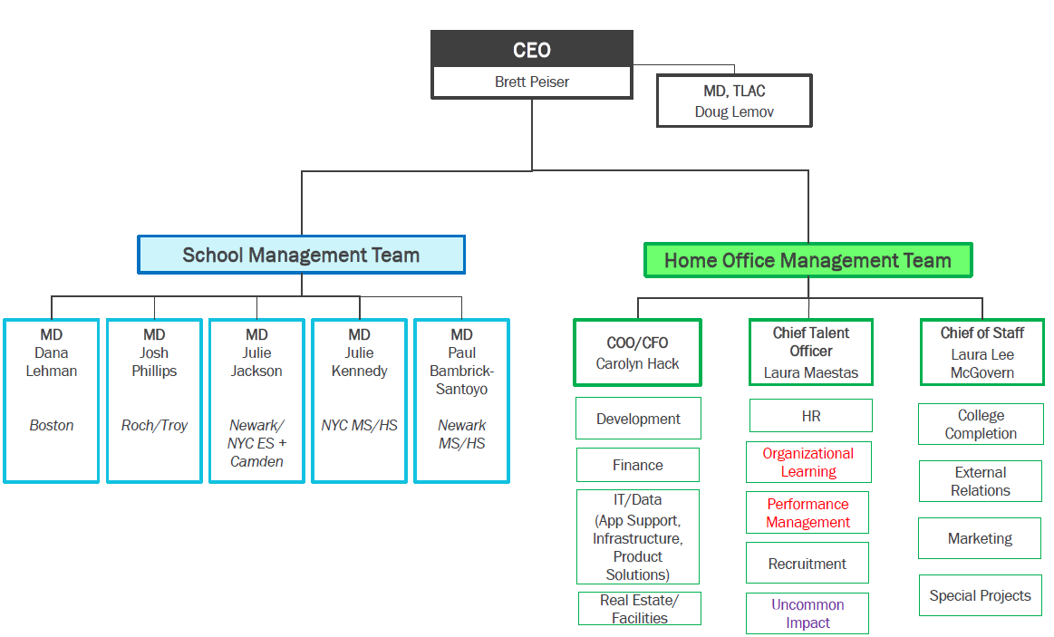
Source: Company documents.

Exhibit 3Sample of North Star Academy’s Cultural Rubric for Breakfast, 2011-2012
Rating | Description
Advanced | o Brain Breakfasts (BB) and breakfasts set out at 7:00 by custodian  o Teacher monitors are on time and are actively monitoring  o Room is silent  o 95% of students are doing BB or independent reading without reminder  o 100% of students are seated or moving with permission  o 90% of students have arrived 5 minutes prior to Community Circle (Circle)  o Transition to Circle is quiet and quick  o Homework (HW) collection system runs seamlessly and requires no management from school leaders  o Systems guarantee that students leave eating area clean
Proficient | o BB and breakfasts set out at 7:00 by custodian  o Teacher monitors are on time and are mostly actively monitoring  o Room is silent  o 90% of students are doing BB or independent reading without reminder  o 90% of students are seated or moving with permission  o 85% of students have arrived 5 minutes prior to Circle  o Transition to Circle is quiet and quick  o HW collection system runs seamlessly and requires no management from school leaders  o Systems guarantee that students leave eating area clean
Working Towards | o BB and breakfasts are not yet set out upon student arrival at 7:00  o Teacher monitors are late and/or not actively monitoring  o Frequent reminders must be made to keep the room silent  o 80% of students are doing BB or independent reading without reminder  o A significant number of students are moving about the cafeteria without permission  o 80% of students have arrived 5 minutes prior to Circle  o Transition to Circle is inefficient  o HW collection system requires management from school leaders  o Some students clean up in eating area, but cafeteria is left somewhat messy
Needs Improvement | o BB and breakfasts are not yet set out upon student arrival at 7:00  o Teacher monitors are late and are not actively monitoring  o Frequent reminders must be made to keep the room silent  o Less than 80% of students are doing BB or independent reading without reminder  o A significant number of students are moving without permission  o Less than 80% of students have arrived 5 minutes prior to Circle  o Transition to Circle is inefficient requiring correction from teachers and school leaders  o HW collection system is not in place  o Cafeteria is left messy
Source: Adapted from Uncommon Schools documents via The New Teacher Project, “Uncommon Schools (North Star Academy),” http://tntp.org/teacher-talent-toolbox/partner/uncommon-schools-north-star-academy, accessed December 2016.

Exhibit 4A Typical School Day at Uncommon
- An earlier start-time than most public schools. Our students need to make tremendous gains in reading and math, among other subjects, in order to be college-ready. We extend the school day because at Uncommon, more time in school means more learning.
- A school leader eagerly waiting to shake hands with students as they arrive. We believe it’s important for students to know that every day, we are glad to see them, and we are excited for what they will accomplish.
- Breakfast. The majority of Uncommon students qualify for free or reduced-price meals.
- Literacy. From Kindergarten through 12th grade, we place a huge emphasis on literacy. As our young students move from “learning to read” to “reading to learn,” and as our older students transition from comprehension into deep textual analysis, we keep our eye on college as the goal.
- Math. Most Uncommon schools devote twice the time to math than local district schools. Math procedures and problem-solving skills are vital to the overall development of critical thinking skills, and they unlock access to compelling future subject area pursuits like physics and engineering.
- Lunch. Observing lunchtime at an Uncommon school is like observing a well-choreographed dance. Everyone knows where to be, where to go, and what to do. We maintain tight processes around everything from lunch lines for food distribution to entering and exiting bench tables. What results is a full lunch period reserved for fueling up for the afternoon's lessons.
- Physical Education. Uncommon schools provide physical education, ranging from once a week to daily. We believe it’s important for students to have the opportunity to move, to collaborate, to compete, and to re-charge.
- Subject Area Classes. Uncommon schools teach a range of courses in history, science, and the arts.
- Music/Drama/Art. Many Uncommon schools provide music, drama, and art classes as a core component of the weekly schedule. We value the arts as a disciplined and creative pursuit that will benefit students throughout their lives.
- Afternoon Enrichment. All Uncommon middle and high schools offer afternoon enrichment. Specific courses vary but include activities such as book club, jewelry making, capoeira, musical theater, basketball, woodworking, and chorus.
- Dismissal. It’s important to end the day on the right foot, because we’ll all be together again tomorrow, working toward the same goal of college. Our schools have very structured dismissal procedures that allow for smooth transitions from classrooms to the sidewalk to buses. Adults are ever-present, saying goodbye to students, providing positive reinforcement for the work they’ve accomplished today, and encouraging them on tonight’s homework assignment.
Source: Adapted from “A Typical Day,” Uncommon Schools, http://www.uncommonschools.org/our-schools/a-typical-days, accessed November 2016.

Exhibit 5Uncommon School Openings, 2005-2013
Year | School | Location
1997 | North Star Academy - Downtown Middle School | Newark, NJ
1999 | Roxbury Prep - Mission Hill Campus | Boston, MA
2000 | North Star Academy - Washington Park High School | Newark, NJ
2004 | Excellence Boys Charter School Elementary Academy | Brooklyn, NY
2005 | North Star Academy - Clinton Hill Middle School | Newark, NJ
2005 | Williamsburg Collegiate Charter School | Brooklyn, NY
2006 | Leadership Prep Bedford Stuyvesant Elementary Academy | Brooklyn, NY
2006 | Rochester Prep Middle School – Brooks Campus | Rochester, NY
2007 | North Star Academy - Vailsburg Elementary School | Newark, NJ
2007 | Kings Collegiate Charter School | Brooklyn, NY
2008 | Excellence Boys Charter School Middle Academy | Brooklyn, NY
2008 | Bedford Stuyvesant Collegiate Charter School | Brooklyn, NY
2009 | Excellence Girls Charter School Elementary Academy | Brooklyn, NY
2009 | Leadership Prep Brownsville Elementary Academy | Brooklyn, NY
2009 | Brownsville Collegiate Charter School | Brooklyn, NY
2009 | Uncommon Charter High School | Brooklyn, NY
2009 | Troy Prep Middle School | Troy, NY
2010 | North Star Academy - West Side Park Elementary School | Newark, NJ
2010 | North Star Academy - Vailsburg Middle School | Newark, NJ
2010 | Leadership Prep Ocean Hill Elementary Academy | Brooklyn, NY
2010 | Leadership Prep Bedford Stuyvesant Middle Academy | Brooklyn, NY
2010 | Ocean Hill Collegiate Charter School | Brooklyn, NY
2010 | Brooklyn East Collegiate Charter School | Brooklyn, NY
2010 | Rochester Prep Elementary School | Rochester, NY
2011 | North Star Academy - Fairmount Elementary School | Newark, NJ
2011 | Rochester Prep Middle School – West Campus | Rochester, NY
2011 | Roxbury Prep - Lucy Stone Campus | Boston, MA
2011 | Troy Prep Elementary School | Troy, NY
2012 | North Star Academy - Liberty Elementary School | Newark, NJ
2012 | North Star Academy - West Side Park Middle School | Newark, NJ
2012 | Uncommon Collegiate Charter High School | Brooklyn, NY
2012 | Roxbury Prep Charter School - Dorchester Campus | Boston, MA
2013 | Rochester Prep Elementary School – West Campus | Rochester, NY
2013 | Leadership Prep Canarsie Elementary Academy | Brooklyn, NY
2013 | Leadership Prep Canarsie Middle Academy | Brooklyn, NY
2013 | Leadership Prep Ocean Hill Middle Academy | Brooklyn, NY
2013 | Excellence Girls Charter School Middle Academy | Brooklyn, NY
2013 | Leadership Prep Brownsville Middle Academy | Brooklyn, NY
Source: Company documents.
Note: Roxbury Prep Charter School, Mission Hill Campus was founded in 1999 and formally joined the Uncommon network in 2010.

Exhibit 6Uncommon’s Charter School Locations, July 2013
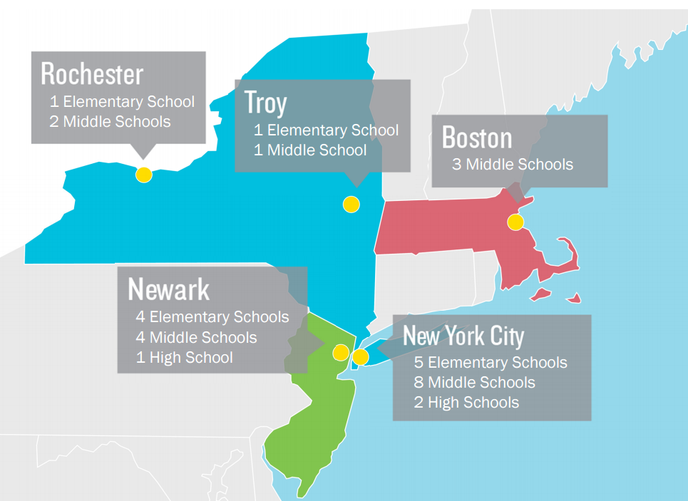
Source: Company documents.

Exhibit 7Regional Demographics and Charter School Funding, 2010
 | Boston, MA | Newark, NJ | New York City, NY | Rochester, NY | Troy, NY
Population | 617,594 | 277,140 | 8,175,133 | 210,565 | 50,129
Under 18 years old | 16.8% | 25.6% | 21.6% | 24.8% | 20.2%
Black or African American | 24.4% | 52.4% | 25.5% | 41.7% | 16.4%
American Indian | 0.4% | 0.6% | 0.7% | 0.5% | 0.3%
Asian | 8.9% | 1.6% | 12.7% | 3.1% | 3.4%
Hispanic or Latino | 17.5% | 33.8% | 28.6% | 16.4% | 7.9%
White, not Hispanic or Latino | 47.0% | 11.6% | 33.3% | 37.6% | 69.7%
Median household income | $55,777 | $33,139 | $53,373 | $30,960 | $38,954
Persons in poverty | 21.5% | 29.7% | 20.6% | 33.5% | 26.1%
Charter schools
State Aid Per Pupil (FY13) | $13,595 | $14,535 | $13,527 | $12,089 | $15,024
Source: Compiled from company documents and United States Census, QuickFacts, http://www.census.gov/quickfacts/table/PST045215/00, accessed December 2016.
Note: Per pupil funding data represents Uncommon’s specific funding in each district; excludes additional funding for special education students.

Exhibit 8Uncommon Growth: Key Statistics, 2005-2006 to 2012-2013
School Statistics
School Year | 2005-06 | 2006-07 | 2007-08 | 2008-09 | 2009-10 | 2010-11 | 2011-12 | 2012-13
Total Schools | 5 | 7 | 9 | 11 | 16 | 24 | 28 | 32
Total Students | 572 | 927 | 1,375 | 1,939 | 2,863 | 4,556 | 6,121 | 7,909
NYC | 204 | 420 | 647 | 969 | 1,657 | 2,503 | 3,268 | 4,095
Newark | 368 | 434 | 582 | 753 | 901 | 1,249 | 1,687 | 2,158
Rochester | - | 73 | 146 | 217 | 251 | 450 | 637 | 785
Troy | - | - | - | - | 54 | 107 | 217 | 318
Boston | - | - | - | - | - | 247 | 312 | 553
Total Teachers | 58 | 107 | 158 | 220 | 283 | 445 | 597 | 728
Financials ($ millions)
FY Ending June 30 | 2006 | 2007 | 2008 | 2009 | 2010 | 2011 | 2012 | 2013
Revenue
Contributions | 3.24 | 4.81 | 7.60 | 11.38 | 17.31 | 10.28 | 13.68 | 15.01
Govt Grants | 0 | 0 | 0 | 0 | 0.09 | 1.32 | 1.89 | 2.75
Program Services | 0.34 | 0.85 | 1.63 | 3.42 | 5.14 | 8.18 | 11.27 | 23.26
Investments | 0.25 | 0.32 | 0.35 | (0.64) | 1.64 | 2.05 | 5.77 | 4.01
Total Revenue | $3.82 | $5.99 | $9.59 | $14.17 | $24.18 | $21.83 | $32.62 | $45.04
Expenses
Program Services | 13.02 | 4.84 | 6.68 | 7.76 | 16.69 | 18.28 | 24.40 | 26.90
Admin | 0.11 | 0.21 | 0.53 | 0.54 | 0.58 | 1.14 | 1.26 | 1.12
Fundraising | 0 | 0 | 0.10 | 0.20 | 0.29 | 0.51 | 0.51 | 0.56
Total Expenses | $13.13 | $5.06 | $7.32 | $8.51 | $17.56 | $19.93 | $26.18 | $28.58
Net Gain/Loss | ($9.30) | $0.93 | $2.27 | $5.65 | $6.62 | $1.90 | $6.44 | $16.46
Source: Compiled from Uncommon Schools, “Uncommon 101,” available at http://www.socialimpactexchange.org/sites/www.socialimpactexchange.org/files/Uncommon%20101-New%20version%20of%20biz%20plan.pdf, “Uncommon Schools Inc.,” Guidestar profile, https://www.guidestar.org/profile/31-1488698, both accessed November 2016, and company documents.
Note: Numbers may not add up to totals due to rounding.

Exhibit 9New York State Standards vs. Common Core State Standards
New York State Standards |  |  | Common Core State Standards
Grade 4 Reading
Fluency |  |  | Fluency
Sight-read automatically high-frequency words and irregularly spelled content words  Read with confidence from a variety of grade-level texts with appropriate speed, accuracy, and expression |  | Read with sufficient accuracy and fluency to support comprehension.  a. Read grade-level text with purpose and understanding.  b. Read grade-level prose and poetry orally with accuracy, appropriate rate, and expression on successive readings.  c. Use context to confirm or self-correct word recognition and understanding, rereading as necessary.
Grade 6 Math
Geometry |  |  | Geometry
Students will use visualization and spatial reasoning to analyze characteristics and properties of geometric shapes.  6.G.1 Calculate the length of corresponding sides of similar triangles, using proportional reasoning  6.G.2 Determine the area of triangles and quadrilaterals (squares, rectangles, rhombi, and trapezoids) and develop formulas  6.G.3 Use a variety of strategies to find the area of regular and irregular polygons  6.G.4 Determine the volume of rectangular prisms by counting cubes and develop the formula  6.G.5 Identify radius, diameter, chords and central angles of a circle  6.G.6 Understand the relationship between the diameter and radius of a circle  6.G.7 Determine the area and circumference of a circle, using the appropriate formula  6.G.8 Calculate the area of a sector of a circle, given the measure of a central angle and the radius of the circle  6.G.9 Understand the relationship between the circumference and the diameter of a circle  Students will apply coordinate geometry to analyze problem solving situations.  6.G.10 Identify and plot points in all four quadrants  6.G.11 Calculate the area of basic polygons drawn on a coordinate plane (rectangles and shapes composed of rectangles having sides with integer lengths) |  | Solve real-world and mathematical problems involving area, surface area, and volume.  1. Find the area of right triangles, other triangles, special quadrilaterals, and polygons by composing into rectangles or decomposing into triangles and other shapes; apply these techniques in the context of solving real-world and mathematical problems.  2. Find the volume of a right rectangular prism with fractional edge lengths by packing it with unit cubes of the appropriate unit fraction edge lengths, and show that the volume is the same as would be found by multiplying the edge lengths of the prism. Apply the formulas V = l w h and V = b h to find volumes of right rectangular prisms with fractional edge lengths in the context of solving real-world and mathematical problems.  3. Draw polygons in the coordinate plane given coordinates for the vertices; use coordinates to find the length of a side joining points with the same first coordinate or the same second coordinate. Apply these techniques in the context of solving real-world and mathematical problems.  4. Represent three-dimensional figures using nets made up of rectangles and triangles, and use the nets to find the surface area of these figures. Apply these techniques in the context of solving real-world and mathematical problems.
Source: Compiled from English Language Arts and Math standards, available at “New York State Learning Standards and Core Curriculum,” New York State Education Department, March 26, 2014, http://www.p12.nysed.gov/ciai/common_core_standards/, accessed February 2017.

Exhibit 10New York: Students Scoring Proficient or Advanced (%), 2009-2010 to 2012-2013
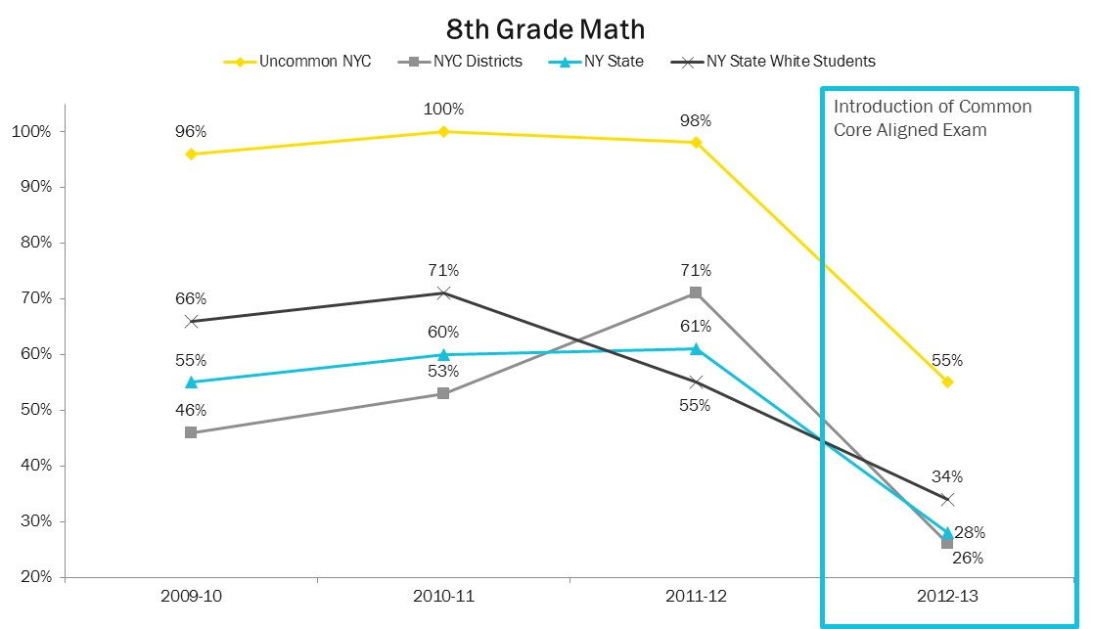
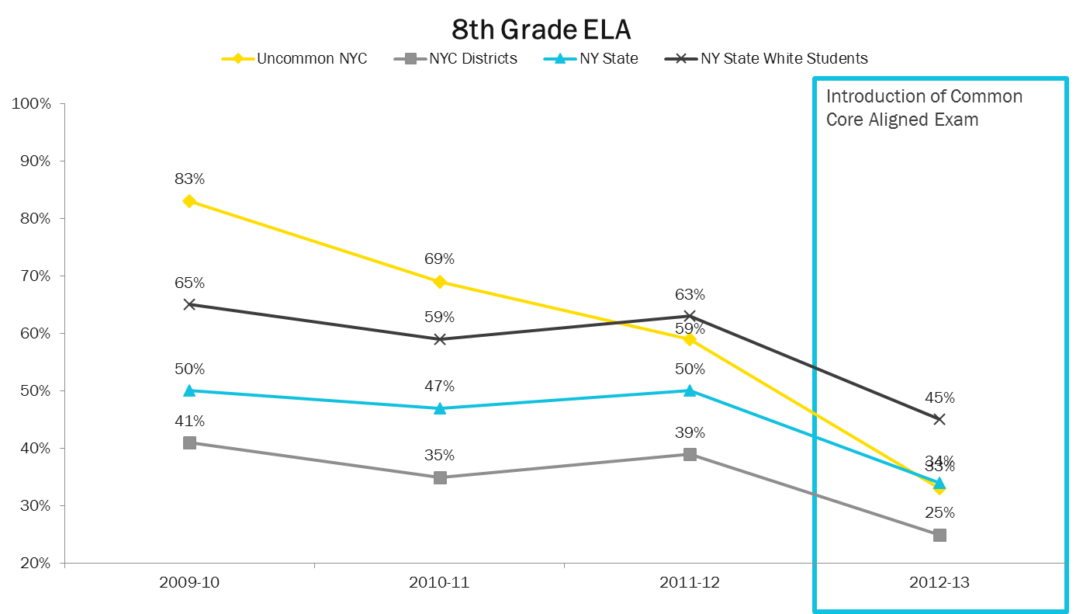
Source: Company documents.

Exhibit 11Uncommon Regions: Students Scoring Proficient or Advanced by Grade (%), 2012-2013
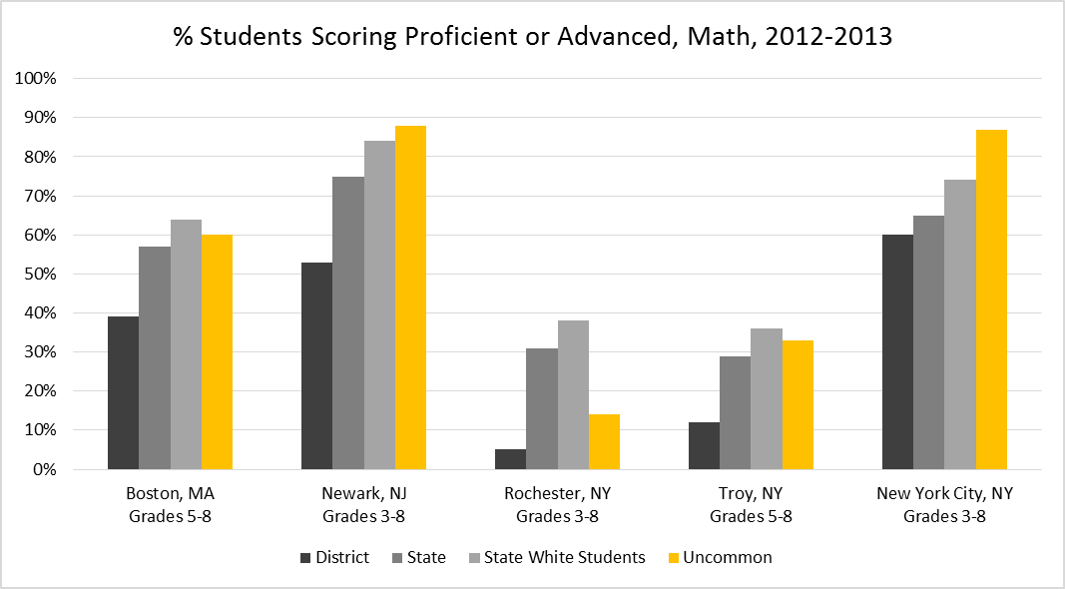
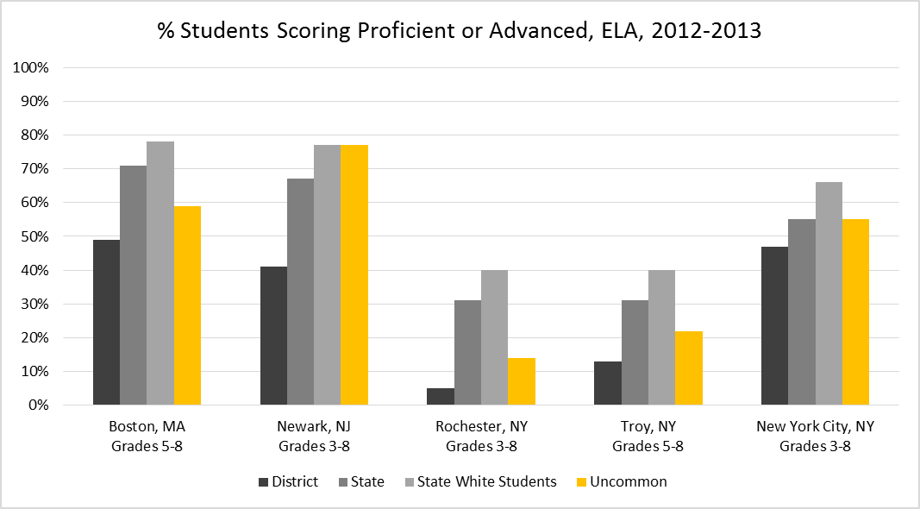
Source: Company documents.
Note: The Uncommon averages represented the number of students in schools in that region who scored proficient or advanced divided by the total number of students in the region.
Boston: 80% of Uncommon 5th graders were in their first year at an Uncommon school.
Newark: 75% of Uncommon 5th graders were in their first year at an Uncommon school.
Rochester: 92% of Uncommon 5th graders were in their first year at an Uncommon school and Uncommon Rochester did not have any 4th grade students enrolled in 2012-2013.
Troy: 95% of Uncommon 5th graders were in their first year at an Uncommon school.
New York City: 80% of Uncommon 5th graders were in their first year at an Uncommon school.

Exhibit 12New York City: Uncommon vs. District Middle Schools, % Students Scoring Proficient or Advanced, 2011-2013
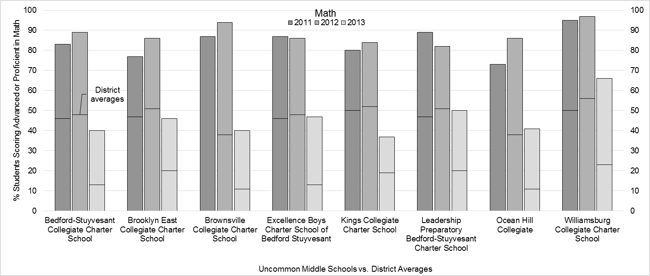
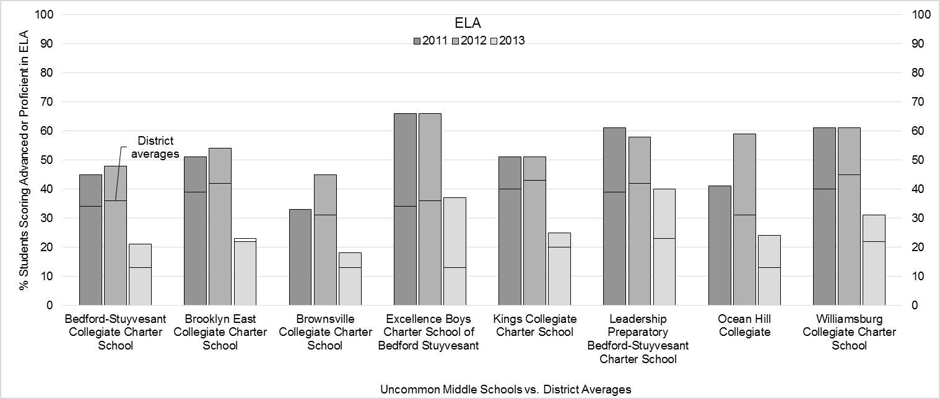
Source: Casewriter, compiled from “NYC Charter Schools Among Bright Spots as State Sets New Baseline,” New York City Charter School Center, August 7, 2013, http://www.nyccharterschools.org/blog/nyc-charter-schools-among-bright-spots-state-sets-new-baseline, accessed December 2016.
Note: Horizontal bars represent the results for the school’s district. For example, in 2011, 45% of students at Bedford-Stuyvesant Collegiate Charter School earned proficient or above in ELA, compared to 34% of students in the district.
District data unavailable for Excellence Boys Charter School of Bedford-Stuyvesant or Ocean Hill Collegiate in 2011.
Data for Excellence Boys Charter School of Bedford-Stuyvesant and Leadership Preparatory Bedford-Stuyvesant Charter School include 3rd and 4th graders.

Exhibit 13New York: Percent Students Scoring Advanced or Proficient, 2012-2013
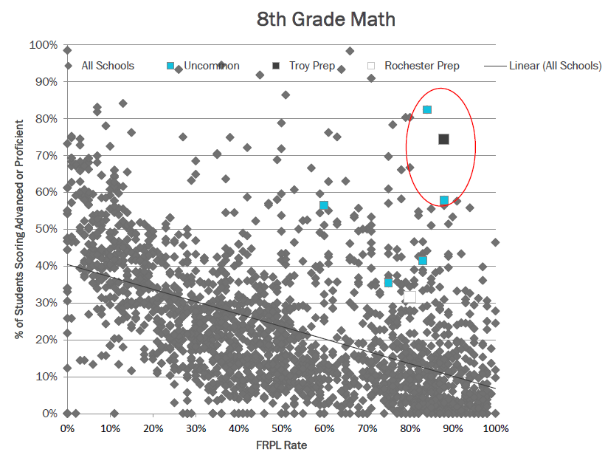
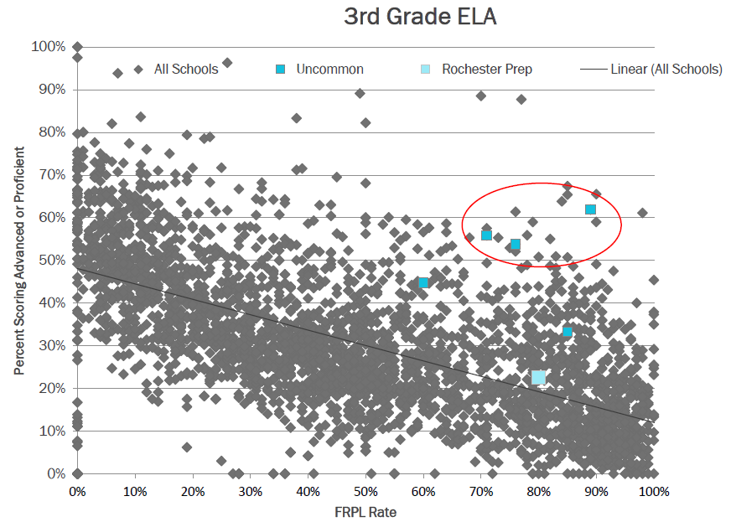
Source: Company documents.
Note: FRPL = Free or reduced price lunch.
Endnotes

Uncommon Schools, “Our Mission,” http://www.uncommonschools.org/our-approach/the-opportunity-gap, accessed October 2016.
“Uncommon Schools Wins 2013 Broad Prize for Public Charter Schools,” Broad Foundation press release, July 2, 2013, http://broadfoundation.org/uncommon-schools-wins-2013-broad-prize-public-charter-schools/, accessed November 2016.
National Charter School Resource Center, “What is a Charter School?” NCSRC website, https://www.charterschoolcenter.org/what-is-a-charter-school, accessed November 2016.
National Charter School Resource Center.
National Center for Education Statistics, “Charter School Enrollment,” NCES website, http://nces.ed.gov/programs/coe/indicator_cgb.asp, accessed November 2016.
National Center for Education Statistics, Table 216.30, NCES website, http://nces.ed.gov/programs/digest/d15/tables/dt15_216.30.asp?current=yes, accessed November 2016.
National Center for Education Statistics, Table 216.30.
Urban Charter School Study press release, “CREDO Study Finds Urban Charter Schools Outperform Traditional School Peers,” March 18, 2015, http://urbancharters.stanford.edu/news.php, accessed February 2017.
Center on Reinventing Public Education, “Charter-School Management Organizations: Diverse Strategies and Diverse Student Impacts” (PDF file), downloaded from CRPE website, http://www.crpe.org/sites/default/files/pub_cmofinal_Jan12_0.pdf, accessed November 2016.
Laura Waters, “The Key to Charter School Success Is Collaboration With District Schools,” Education Post, http://educationpost.org/the-key-to-charter-school-success-is-collaboration-with-district-schools/, accessed October 2016.
Ashoka website, “Norman Atkins,” https://www.ashoka.org/en/fellow/norman-atkins, accessed October 2016.
Richard Whitmire, The Founders: Inside the revolution to invent (and reinvent) America’s best charter schools, p. 51, available at http://thefounders.the74million.org/, accessed December 2016.
Richard Whitmire, The Founders . . ., p. 43.
Richard Whitmire, The Founders . . ., p. 43.
Peter Meyer, “Uncommon Success,” Education no. 14, vol. 3, summer 2014, via ABI/ProQuest, accessed October 2016.
Ashoka website.
Ashoka website.
Uncommon Schools, “Uncommon|2021 Project Narrative,” 2016, p. 37, http://innovation.ed.gov/files/2016/10/uncommonschlsPN.pdf, accessed November 2016.
Uncommon Schools Application for Federal Assistance SF-424, July 7, 2010, p. 55, via U.S. Department of Education, https://www2.ed.gov/programs/charter-rehqcs/2010/uncommonapp.pdf, accessed October 2016.
Jenn Hatfield and Ian Lindquist, “Scaling Up: Successes and Challenges of Growing High-Quality Charter Networks,” American Enterprise Institute, May 2016, p. 5, https://www.aei.org/wp-content/uploads/2016/05/Scaling-Up.pdf, accessed November 2016.
Uncommon Schools Application for Federal Assistance SF-424, p. 55. “Associate Chief Operating Officer, Uncommon Schools,” Bain Social Impact, http://www.socialimpactatbain.com/about/our-people/profile-michael-dauria.aspx, accessed November 2016.
Richard Whitmire, “A ‘Founders’ Excerpt: How 4 Visionary Entrepreneurs Joined Forces to Launch Uncommon Schools,” The 74 Million, December 7, 2016, https://www.the74million.org/article/a-founders-excerpt-how-4-visionary-entrepreneurs-joined-forces-to-launch-uncommon-schools, accessed December 2016.
Uncommon Schools Application for Federal Assistance SF-424, p. 54.
Uncommon Schools Application for Federal Assistance SF-424, p. 54.
Uncommon Schools Application for Federal Assistance SF-424, p. 54.
Richard Whitmire, The Founders . . ., p. 164.
NewSchools Venture Fund, “Key Strategies from NewSchools’ Portfolio Ventures,” June 2008, p. 6, https://dschool.stanford.edu/sandbox/groups/k12/wiki/f329e/attachments/89f46/Team%204%20dashboard.pdf?sessionID=b11a8db42ec775eccce2d52685da316b056ca0db, accessed November 2016.
NewSchools Venture Fund.
Paul Bambrick-Santoyo, Leverage Leadership: A Practical Guide to Building Exceptional Schools (San Francisco: Jossey-Bass: 2012), p. 24.
Elizabeth Green, “Building a Better Teacher,” The New York Times Magazine, March 2, 2010, http://www.nytimes.com/2010/03/07/magazine/07Teachers-t.html, accessed November 2016.
Elizabeth Green.
Paul Bambrick-Santoyo in Michael Kaplan, “Places of Learning,” Fast Company, November 2012, p. 52, via EBSCOhost, accessed February 2017.
Elizabeth Green.
Elizabeth Green.
Elizabeth Green.
Stephanie Banchero, “Charter Schools Receive a Passing Grade,” The Wall Street Journal, June 25, 2013, http://www.wsj.com/articles/SB10001424127887323998604578565971195631736, accessed December 2016.
Norman Atkins interview in Richard Whitmire, “A ‘Founders’ Excerpt.”
Bambrick-Santoyo, Leverage Leadership, p. 1.
Bambrick-Santoyo, Leverage Leadership, p. 1.
Norman Atkins interview in Richard Whitmire.
Uncommon Schools Application for Federal Assistance SF-424, p. 80.
Normal Atkins in Richard Whitmire.
Normal Atkins in Richard Whitmire.
Kevin Carey, “’Teacher U’: A New Model in Employer-Led Higher Education,” The Chronicle of Higher Education, December 9, 2009, http://www.chronicle.com/article/Teacher-U-A-New-Model-in/49442/, accessed October 2016.
Uncommon Schools, “Uncommon Impact Sharing Best Practices,” http://www.uncommonschools.org/uncommon-impact, accessed October 2016.
Uncommon Schools Application for Federal Assistance SF-424, p. 22.
Zearn, “About Us,” https://www.zearn.org/about_us, accessed October 2016.
Richard Whitmire, The Founders . . ., p. 56-57.
“Uncommon Schools,” Social Impact Exchange, 2016, http://www.socialimpactexchange.org/organization/uncommon-schools#, accessed November 2016.
James L. Woodworth and Margaret E. Raymond, “Charter School Growth and Replication,” Center for Research on Education Outcomes, January 30, 2013, p. 85, https://credo.stanford.edu/pdfs/CGAR%20Growth%20Volume%20II.pdf, accessed November 2016.
Katie Yezzi, “At Work, Practice Puts Perfection in Reach,” The New York Times, November 24, 2012, http://www.nytimes.com/2012/11/25/jobs/in-the-workplace-practice-puts-perfection-in-reach.html, accessed November 2016.
Karin Gerald, “North Star Academy Charter School,” Report Card Narratives: New Jersey Department of Education, 2015, http://www.nj.gov/education/pr/1415/narrative/80/7320/960.html, accessed December 2016.
Drew Desliver, “College enrollment among low-income students still trails richer groups,” Pew Research Center, January 15, 2014, http://www.pewresearch.org/fact-tank/2014/01/15/college-enrollment-among-low-income-students-still-trails-richer-groups/, accessed December 2016.
Uncommon Schools Application for Federal Assistance SF-424, p. 17.
Uncommon Schools Application for Federal Assistance SF-424, p. 18.
Richard Whitmire, The Founders . . ., p. 132.
Office of Innovation & Improvement, “Uncommon Schools: Boosting Student Achievement and Preparing Students for College and Beyond,” The Education Innovator vol. VI, no. 10, October 17, 2008, p. 1, http://www2.ed.gov/news/newsletters/innovator/2008/1017.pdf, accessed November 2016.
Uncommon Schools Application for Federal Assistance SF-424, p. 80.
Jenn Hatfield and Ian Lindquist, “Scaling Up: Successes and Challenges of Growing High-Quality Charter Networks,” American Enterprise Institute, May 2016, p. 6, https://www.aei.org/wp-content/uploads/2016/05/Scaling-Up.pdf, accessed November 2016.
Uncommon Schools, “Uncommon|2021 Project Narrative,” 2016, p. 37, http://innovation.ed.gov/files/2016/10/uncommonschlsPN.pdf, accessed November 2016.
Uncommon Schools, “Uncommon|2021 Project Narrative,” p. 37.
Richard Whitmire, The Founders . . ., p. 146.
Uncommon Schools Application for Federal Assistance SF-424, p. 37.
Richard Whitmire, The Founders . . ., p. 43.
Richard Whitmire, The Founders . . ., p. 43.
“About the Standards,” Common Core State Standards Initiative, n.d., http://www.corestandards.org/about-the-standards/, accessed November 2016.
Laura Chaveriat, “Common Core State Standards Initiative: Year In Review 2014,” Encyclopædia Britannica, September 26, 2014, https://www.britannica.com/topic/Common-Core-State-Standards-Initiative-1994982, accessed November 2016.
“English Language Arts Standards,” Common Core Standards Initiative, n.d., http://www.corestandards.org/ELA-Literacy/, accessed November 2016.
“Mathematics Standards,” Common Core Standards Initiative, n.d., http://www.corestandards.org/Math/, accessed November 2016.
“About” PARCC website, n.d., http://www.parcconline.org/about, accessed November 2016.
Motoko Rich, “In Raising Scores, 1 2 3 Is Easier Than A B C,” The New York Times, May 29, 2013, http://www.nytimes.com/2013/05/30/education/reading-gains-lag-improvements-in-math.html, accessed November 2016.
Academic Benchmarks, “Common Core State Standards Adoption Map,” 2016, http://academicbenchmarks.com/common-core-state-adoption-map/, accessed December 2016.
“Data Brief . . .,” p. 33.

